

TDS TAX PROJECT

DONE BY M.MALATHI



February 5, 2024

SS MOTORS PVT LTD

SS MOTOR COMPANY PVT LTD

|  |  |
| --- | --- |
| ADDRESS | 2/42 C, D DHANAM NAGAR , KARAYAMPALAYAM,MYLAMPATTI(POST)  COIMBATORE-641062 |
| MOBIE NUMBER | 7397881591 |
| TAN NUMBER | 1022776TAC |
| ACCOUNT NUMBER | ABCD572368AGF |
|  |  |

NATURE OF PAYMENTS

|  |  |
| --- | --- |
| NATURE OF PAYMENTS | RENT AND BUILDINGS AND FURNITURE |
| SECTION | 194I |
| RATE | 10% |
| THRESHOLD LIMIT | 240000 |

WITH GROUP CREATION

1.4.2023- SS MOTOR COMPANY LIABLE TO PAY THE RENT OF 250000 TO SRI AGENCIES , SINCE THE LIABLE AMOUNT EXCEEDS THE EXCEMPTION THE COMPANY DECIDED TO CALCULATED THE TDS AMOUNT ON THE SAME BILL

1.4. 2023 –PAY THE REMAINING AMOUNT TO THE SRI AGENCIES THROUGH THE BANK . THE CHECK NUMBER WAS 00023

1.4.2023-SS MOTORS BOOKED A RENTAL EXPENSES ON FURNITURE 250000 THE COMPANY WOULD LIKE TO DEDUCT THE TDS

1.4.2023 – PAY THE RAMAINING AMOUNT TO THE SRI AGENCIES THROUGH THE BANK . THE CHECK NO WAS 188867

WITHOUT GROUP ONLY LEDGER

1-4-2023 SS MOTORES LIABLE TO PAY 120000 TO THE BUSINESS CONSULTANCY FOR COMMISSION BROKERAGE

1-4-2023 PAY THE REMAINING AMOUNT THROUGH THE BANK

1-4-2023 liable to pay 112360 to dun advertisement

But deduct the amount from only 105000

5)

1-4-2023

Liable to commission 100000

But deduct the tds on the other page

1-4-2023

To bhuvana agencies liable to

Commission 30000

Advertisement 40000

Invoice no pur02

1-4-2023

To vinko company Advance payment adjustment

1-4-2023 120000 for transport

2-4-2023 200000 amount settled

Adjust the advance entry

6) the seller has a low rate certificate (sakthi motors)

For we liable to pay him 200000

But the commission percentage is 5%

But he would like to deduct only 4%

7) 0% rate of tax calculate

Vinothini and co (rent the building)

We liable to 600000

No tax calculated .

8)Deducting on the payment

We are liable to give 800000 for rent a building make tds on payment

9) cancel the TDS amount by using debit note

We are liable to pay the amoun t of 800000 to lakhmimurugan group of companies

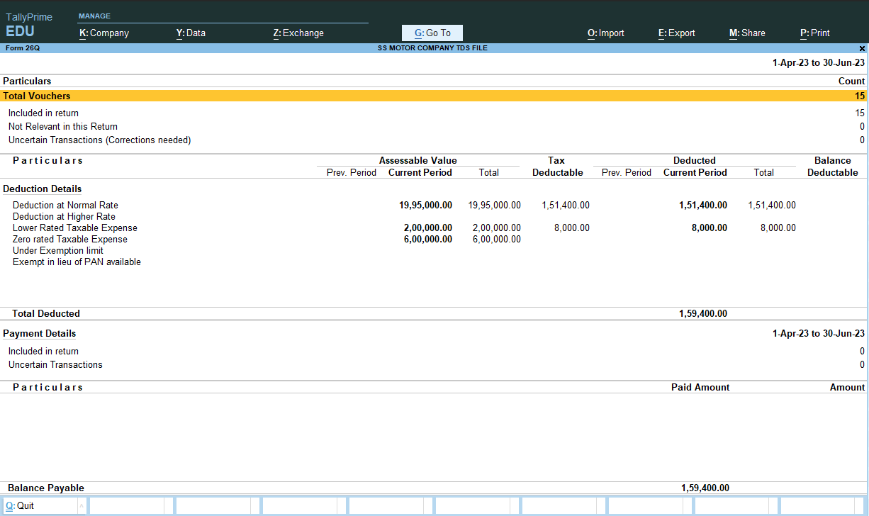

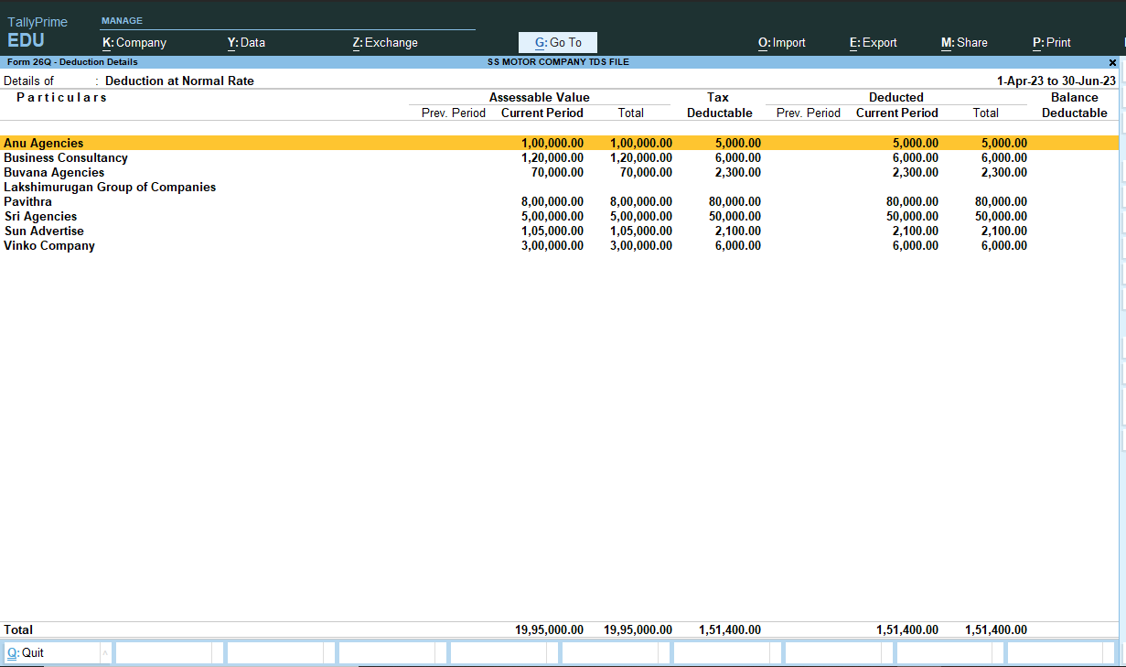

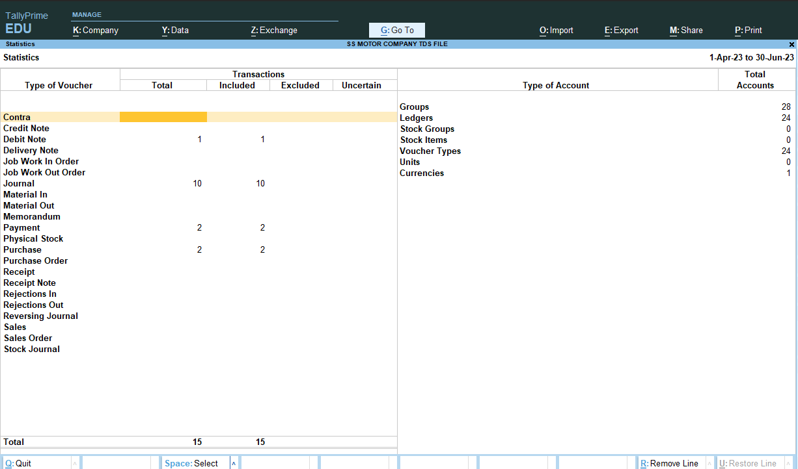

TDS PROJECT COMPLETED